UXM Grade Manager(가제) Project 계획서



2019. 11.

1. Use case diagram

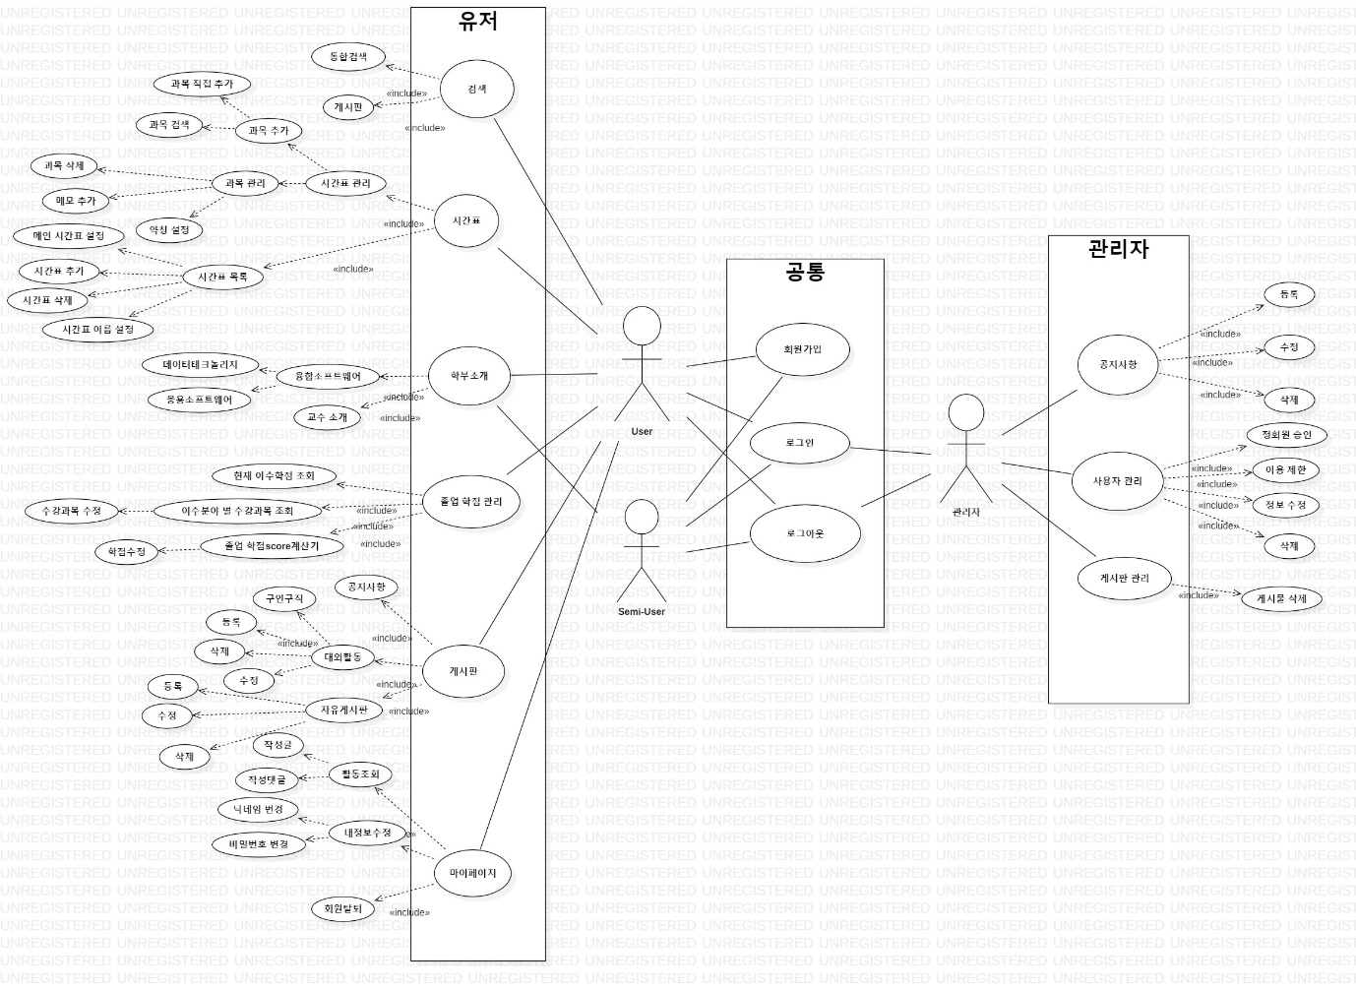

<use case diagram>

1. Sequence diagram
2. 솔

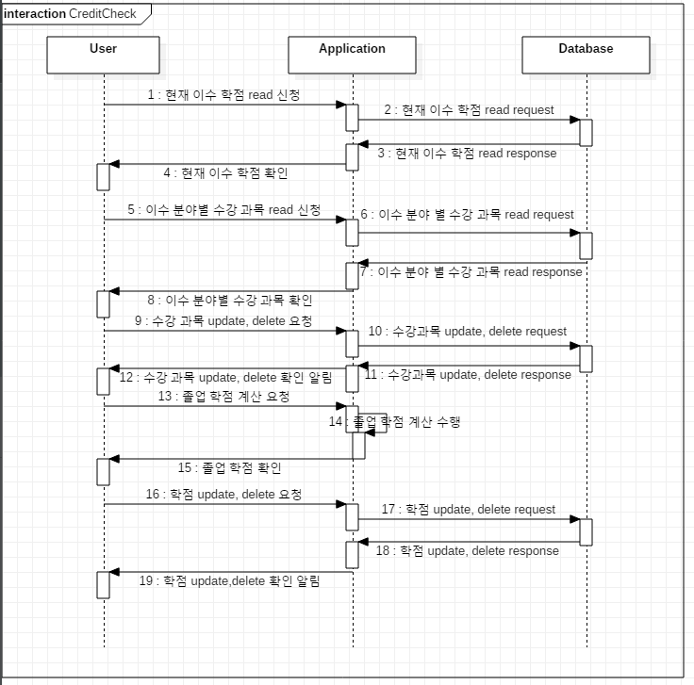

<CreditCheck sequence diagram>

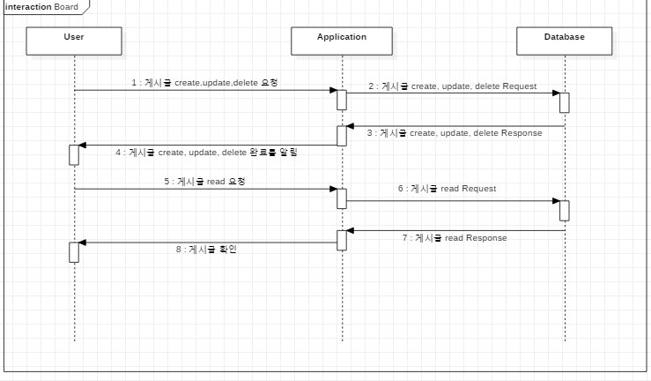

<Board sequence diagram>

1. 원준

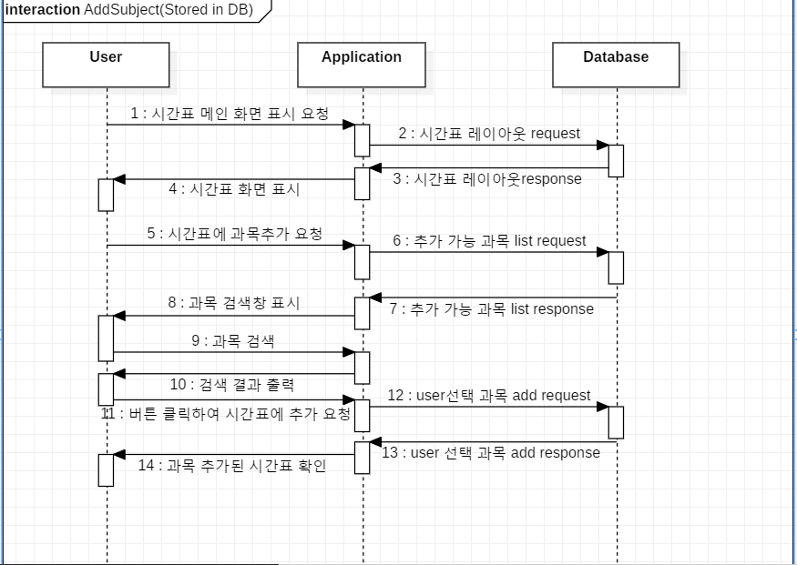

<Addsubject sequence diagram>

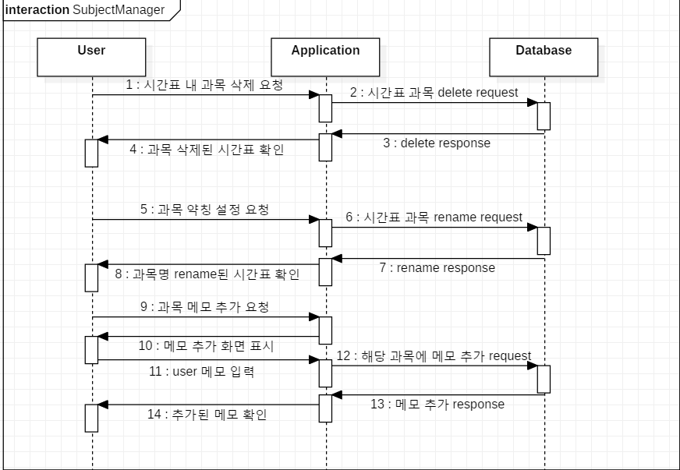

<SubjectManager sequence diagram>

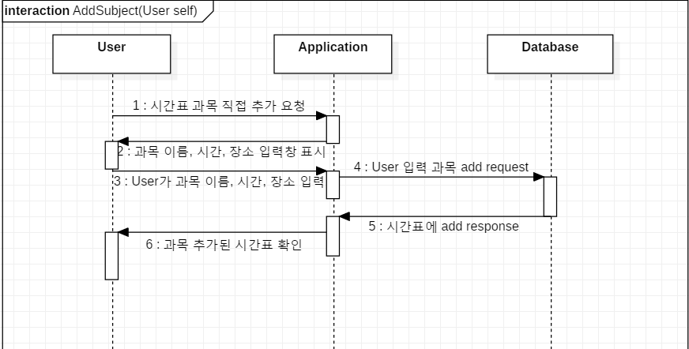

<AddSubject sequence diagram>

1. 성훈

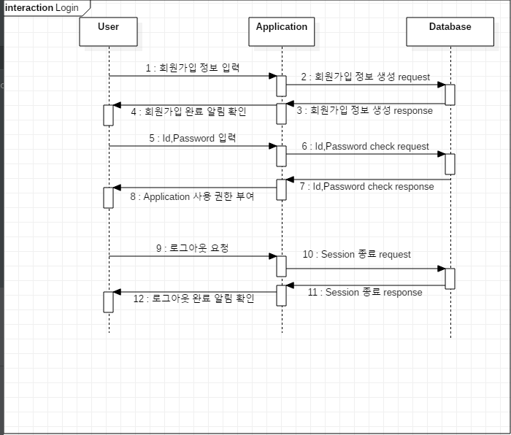

<Login Sequence diagram>

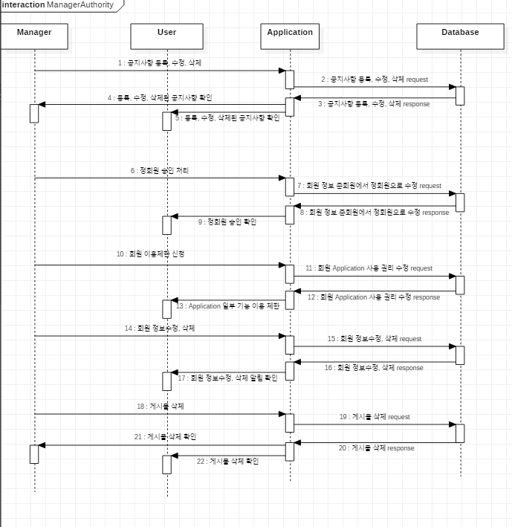

<ManagerAuthority sequence diagram>

1. 도진